Minority Enterprise Development Week 2017



September 25- September 29

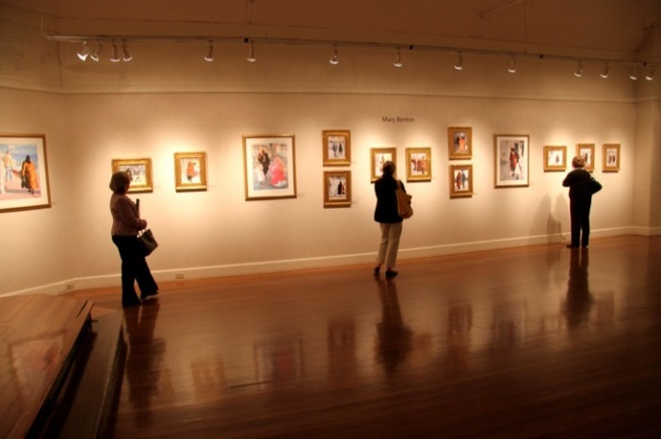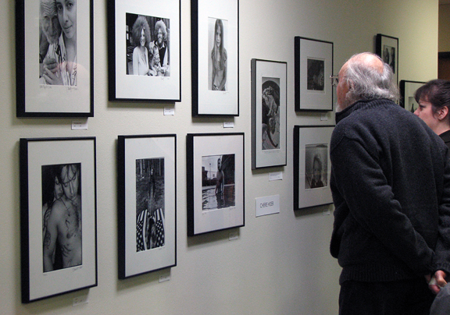

**Evaluation Criteria**

* Overall excellence of the applicant’s artwork and demonstration of exceptional talent.
* Serious professional commitment to art form.
* Contribution of the proposed project to the advancement of the City of Greenville’s artistic culture.
* Feasibility of the proposed project.
* All questions regarding the evaluation should be directed to Ferdinand Rouse at 252-329-4462.

The City of Greenville in an effort to show our continued support for the culture of Greenville and the greater Greenville area would like to extend an opportunity to all artists within the area to develop a potential visual art exhibit.

* All participants must submit an application on or before 5:00pm September 15, 2017.
* Application must be submitted and signed by one person (responsible party). This person or the company he/she represents will become the recipient of any cash or prize awarded. An individual or team may present a visual art piece to represent a company one entry per person/per team.
* The applicant must meet the qualifications of an Eligible Local Bidder as provided in resolution No. 031-15.
* Applicant must show proof of majority ownership (51%) by one or more of the groups identified in North Carolina General Statute 143-128.4.
* The applicant must not be a City of Greenville or Greenville Utilities Commission Employee.
* The proposed exhibit must be an original work or art.
* The selected art exhibit will receive all donations from our September 29th event that will be matched up to $1000.
* All decisions are final.

Disclaimers:

*Confidentiality is not guaranteed in any way. Nondisclosure agreements between a competitor and the judges and/or audience will not be required or allowed. There is no way for the City of Greenville, Greenville Utilities Commission or its affiliates to enforce a prohibition of other competitors, audience members, or judges who see or hear an art design from sharing the concept, idea, and/or materials with others.*

*The City of Greenville, Greenville Utilities Commission, or its affiliates may take photographs and/or video of any materials used or made available by individuals or teams for public relations purpose. Any content presented by a competitor should be considered public knowledge.*

*The City of Greenville, Greenville Utilities Commission, or its affiliates reserve the right to disqualify any entry in its judgement that violates the rules of the competition or is not aligned with the purpose of the competition.*

**Art Exhibit Competition Application**

1. Applicant Name: ______________________ ______________________

(First) (Last)

2. Company Name: ____________________________________________

3. Will you be working with a team? ___Y ___N

If yes, please provide names of all team members:

4. Number of years you have been in business: ______ or _____ N/A

5. Brief summary of your exhibit: 150 words or less (please attach typed narrative)

6. Proof of Ownership Status per N.C.G.S. 143‐128.4*

Applicant may present:

* Copy of state identification and proof of ownership

*The undersigned applicant does hereby submit an Art Exhibit Application for participation in Art Exhibit. Art Exhibit Competition participant, does acknowledge that he or she has read the Art Exhibit, Art Exhibit Competition Eligibility/Rules, does understand the Art Exhibit, Art Exhibit Competition Eligibility/Rules, including the Disclaimers, does agree to comply with the, Art Exhibit Competition Eligibility/Rules, and does grant permission for the City of Greenville, Greenville Utilities Commission, and its affiliates to take photographs and/or video for public relations purposes.*

Signature ________________________________________ ___________________________

Printed name_________________________________________________________________

Date_______________________

** 