Business Resilience Micro-Loan Program
Introduction:
As Downtown Greenville undergoes transformative construction through projects such as the Build Grant and Dickinson Avenue street improvements, it is imperative to support local businesses navigating these changes. Establishment of the Business Resilience Loan Program will address this need and offset potential challenges presented by obstructed access through the commercial area. This program aims to provide financial assistance to downtown-area businesses affected by ongoing construction, enabling them to sustain operations, invest in necessary improvements, and adapt to evolving market conditions.
Program Objectives:
1. Provide financial support to downtown Greenville and emerging area businesses impacted by downtown roadway construction.
2. Foster business resilience and sustainability during the construction phase.
3. Facilitate business growth and adaptation to changing market dynamics.
4. Enhance the vibrancy and economic vitality of downtown Greenville and emerging business districts.
Eligibility Criteria:
Applicants must be commercial business owners located within the Downtown District or emerging commercial area as indicated on the attached map. Tax-exempt entities, such as religious or nonprofit groups, are ineligible for loan funds. Businesses must demonstrate financial need and the ability to repay the loan.
Applicants must submit a detailed plan outlining the intended use of funds and how it will mitigate the impact of construction on their business.
Loan Terms:
Maximum Loan Amount: Up to $10,000
Maximum Term: Up to 3 years
Loan Rate: 0% interest
Payment Deferral: Loan payments may be deferred for the first 6 months following closing
Eligible Expenditures: Inventory, operating supplies, up to 3 months of rent or mortgage payments, minor repairs and maintenance, adding or expanding e-commerce capabilities.
Ineligible Expenditures: Personnel expenses/salaries, furniture, fixtures, interior or exterior building renovations (unless the applicant owns the building), vehicles, or moving expenses unless for relocation within qualifying area as a result of business expansion creating new jobs.
Application Process:
1. Interested businesses must complete the loan application form, providing detailed information about business, financial statements, and proposed use of funds.
2. Applications will be reviewed by the Business Resilience Micro-Loan Committee, consisting of representatives from the City of Greenville.
3. The committee will evaluate each application based on eligibility criteria, financial viability, and the potential impact of the loan on the business and downtown community.
4. Approved applicants will be notified, and loan terms will be finalized.
5. Upon loan disbursement, businesses are required to adhere to reporting requirements, providing regular updates on fund utilization and business performance.
The Business Resilience Mico-Loan Program represents a proactive approach to supporting local businesses during a period of significant change and development. By providing financial assistance and fostering resilience, we aim to ensure the continued success and vitality of downtown-area commerce. This program will contribute to a thriving business ecosystem and a resilient downtown community.

Appendix: Map of Eligible Business District
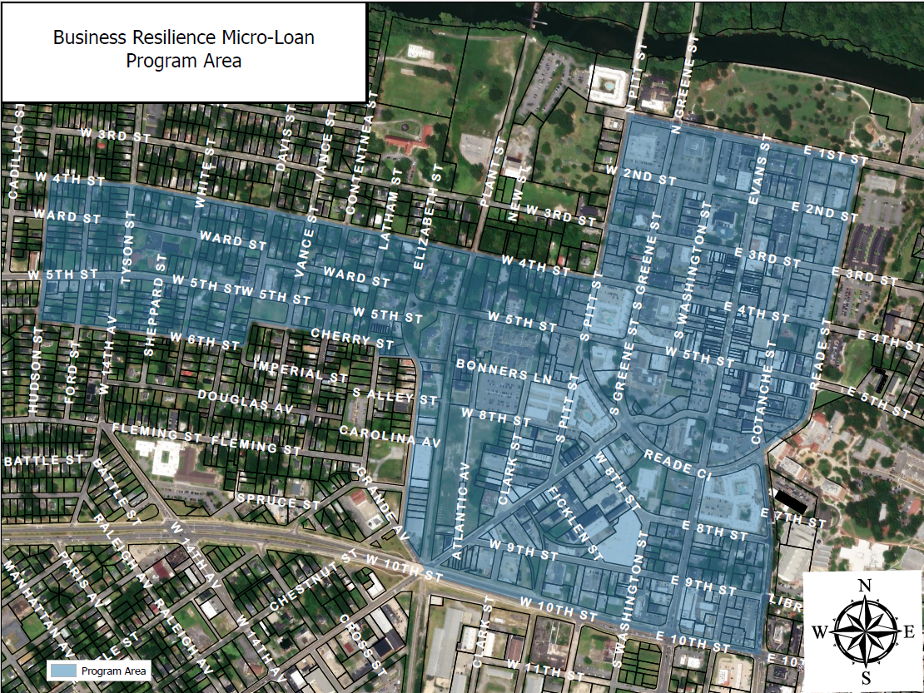

Business Resilience Loan Program Application
Section 1: Business Information
Business Name:
Business Address:
Contact Person:
Phone Number:
Email Address:
Tax ID Number:
Business Type (e.g., Retail, Restaurant, Service, etc.):
Number of Employees:
Section 2: Business Background
Brief Description of Your Business:

How long has your business been operating in Downtown Greenville?

How do you intend to use these funds to offset potential impacts of the downtown area improvements?

Section 3: Loan Request
Amount Requested:
Proposed Use of Funds (Please provide a detailed breakdown):
Inventory:
Equipment:
Rent/Mortgage Payments:
Other (please specify):
Section 4: Financial Information
Annual Revenue (Previous Year):
Projected Annual Revenue (Current Year):
Total Assets:
Total Liabilities:
Net Income (Previous Year):
Net Income (Projected Current Year):
Section 5: Business Plan
Describe any impacts of construction on your business and your plan to utilize the loan funds to mitigate the impact of construction on your business.

Section 6: Supporting Documents
Please attach the following documents:
Business Plan (if available)
Financial Statements (Profit & Loss Statement, Balance Sheet)
Proof of Ownership or Lease Agreement
Any additional documents supporting your loan request
Section 7: Certification
I certify that the information provided in this application is true and accurate to the best of my knowledge. I understand that providing false information may result in disqualification from the Business Resilience Loan Program.
Signature: _____________________________________________
Date:___________________________________________________
Submission Instructions: Please submit the completed application along with the required supporting documents to:
Neighborhood & Business Services Department, Business Development Division
Municipal Building
201 W. Fifth Street
Greenville, NC 27834
Thank you for your interest in the Business Resilience Loan Program. If you have any questions or need assistance completing the application, please contact Business Development at businessinfo@greenvillenc.gov or 252-329-4665.

