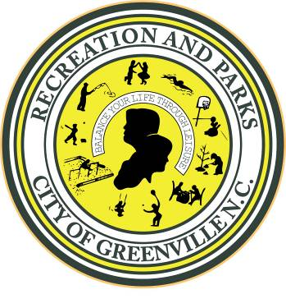 | GREENVILLE RECREATION & PARKS DEPARTMENT  GIFT CATALOGUE  2000 Cedar Lane  Greenville, North Carolina 27858  #841262
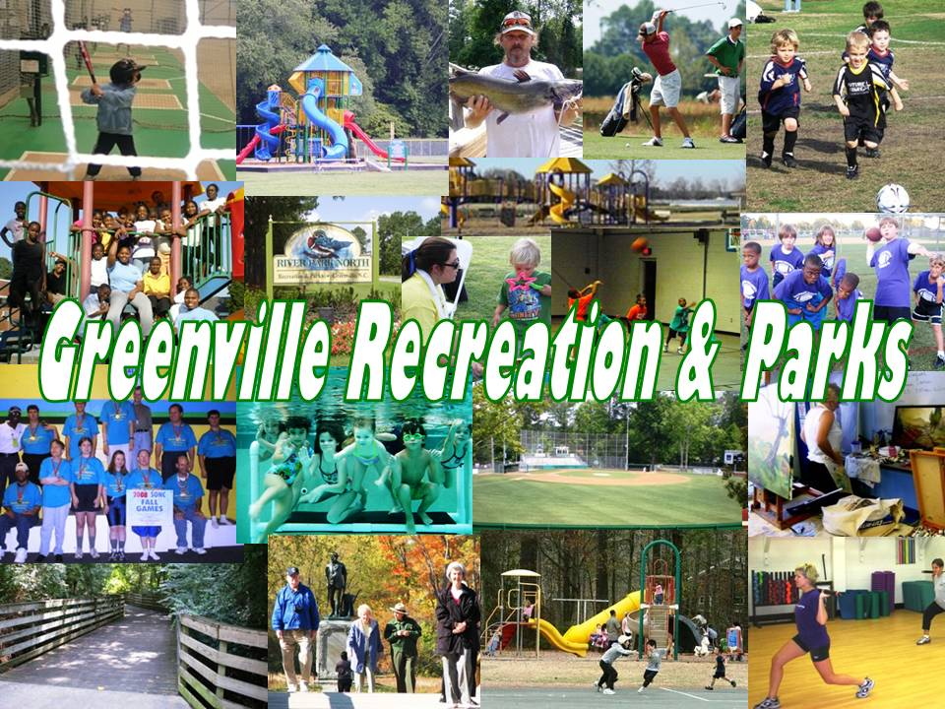

The Recreation & Parks Department’s Gift Catalogue provides you with the opportunity to make a gift that will honor a person or organization, commemorate specials occasions such as births, weddings, family reunions, a loved one, or demonstrate your support for our community.
The following items are examples of potential gifts with associated costs. These costs can vary, particularly with large items such as playground equipment, if the donor is interested in different models or styles. Note that all donated items must conform to our departmental standards for installation, commercial grade equipment, and type.

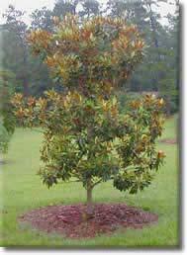
The gift of a tree represents a lasting tribute as it grows and flourishes through the years to come. Trees are an important resource. They produce oxygen, reduce carbon monoxide, add beauty and shade to our parks, and provide wildlife habitat.

In order to ensure that your Gift Tree survives and thrives, we will plant your tree at the horticulturally correct time for our region, November 1 to March 1. Trees will be 2" in caliper and from 8' to 10' tall, depending on species and availability. There are many species that are available for planting, including large trees such as live oak, nut tall oak, willow oak, white oak, deodora cedar, magnolia, or the smaller trees such as Kousa dogwood or flowering camellia.
COST: $250.00
This includes the tree, a commemorative engraved brick mounted in concrete and a one (1) year warranty on the tree.

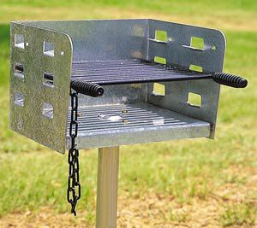

Park Bar-B-Que Grill | Amount
Galvanized Bar-B-Que Grill | $198.00
Additional Required Assembly Materials | $37.00
TOTAL | $235.00

Park Bench – Pressure Treated Wood 6’ x 2’

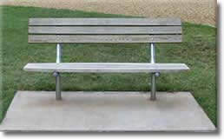

Park Bench – 6’ x 2’ Pressure Treated Wood | Amount
Direct Burial Park Bench | $450.00
Additional Required Assembly Materials | $60.00
Concrete Slab Installation | $30.00
TOTAL | $540.00

Sand Volley Ball Pit with Net Assembly

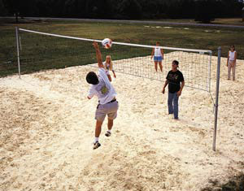

Sand Volley Ball Pit | Amount
Volleyball Nets - Each | $100.00
Volleyball Posts – Set of 2, 5” Galvanized Post | $990.00
Assembly Materials + Shipping | $100.00
Sand | $140.00
TOTAL | $1,300.00
RECYCLE & TRASH CAN INSTALLATION
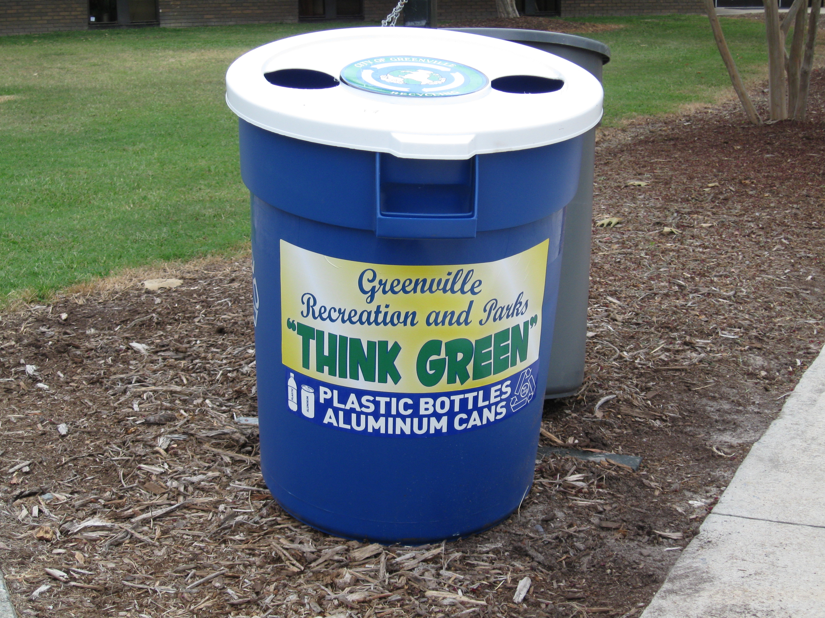

Cans are placed on steel hooks on a post with a regular trash can (in rear) to discourage use of the recycle can for trash. Per manufacture’s specification, a minimum order of 10 cans is required. One memorial brick included per donation. Decals are printed separately and attached.
NUMBER | ITEM | DESCRIPTION | UNIT COST | TOTAL
10  10  10 | 32 Gal. Recycle Can  32 Gal. Trash Can  32 gal Trash Lid | H-1478; 32 Gallon Brute Recycling cans; Blue color (no substitutions); To be delivered to Park Services maintenance shop on New Street.  H-1045GR; GRAY ROUND BRUTE CONTAINER 32GAL  H-1048GR; GRAY BRUTE CONTAINER LID 32 GAL | $35.00  $28.00  $9.00 | $350.00  $280.00  $90.00
10 | 32 gal. Recycle  can lid | H-1048W; White lid for 32 Gallon Brute recycling can | $12.00 | $120.00
1 | 1 | can Shipping charge | $6.50 | $65.00
5 | wood posts | 4"x4"x10' treated pine posts | $14.00 | $70.00
20 | hardware set | manufactured steel hooks for posts | $6.00 | $120.00
5 | bags sacrete | concrete mix to set poles | $5.00 | $25.00
10 | decals | recycle can decals | $2.00 | $20.00
 |  |  | TOTAL: | $1,140.00

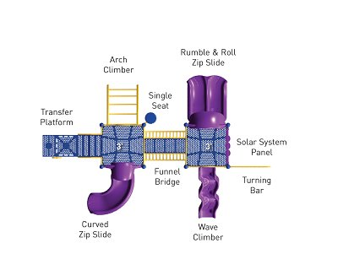
Bridge Point Playground – 2-5 Age Group
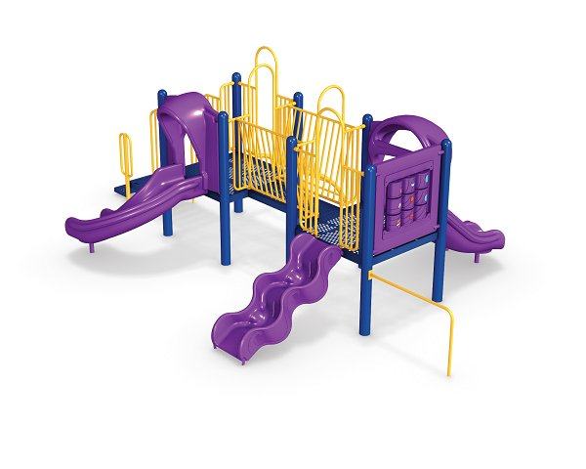

Playground Equipment (2-5 Age Group) Less than $25K | Amount
Playground Equipment | $13,457.00
Installation Fee | $3,344.00
Freight | $252.00
Material Surcharge | $770.00
Safety Surfacing (Engineered Wood Chips) | $6,677.00
TOTAL | $24,500.00

Note: Cost can vary considerably depending on manufactures incentives and other discounts.

Hawks Nest – 5-12 Age Group

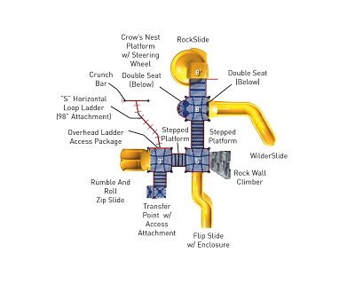
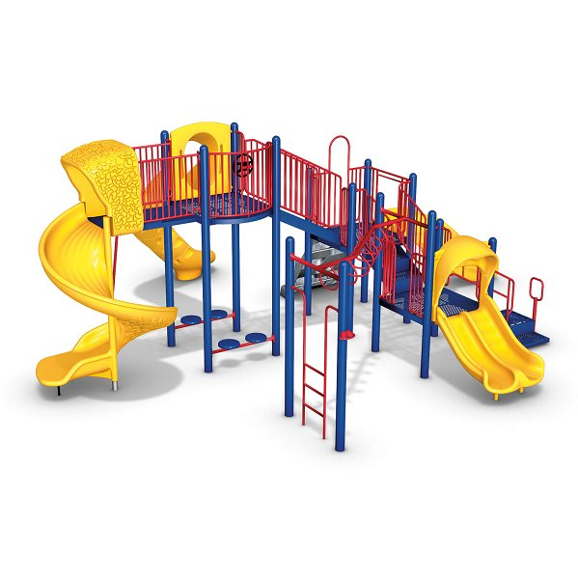

Playground Equipment (2-5 Age Group) $25K - $45K | Amount
Playground Equipment | $28,356.00
Installation Fee | $6,670.00
Freight | $530.00
Material Surcharge | $1,590.00
Safety Surfacing (Engineered Wood Chips) | $13,354.00
TOTAL | $50,500.00

Note: Cost can vary considerably depending on manufactures incentives and other discounts.
Double Faced Dedication Signage with Sponsor’s Logo; available with gifts of $30,000 or more.

Dedication / Partnership Signage (18” x 42” Aluminum) | Amount
Double Faced Aluminum Sign - Each | $375.00
Material Surcharge | $21.00
Freight | $8.00
Concrete Pad and Footings | $26.00
TOTAL | $430.00

AVALABLE WITH DONATION OF $10,000

Dedication Plaque (4” x 4” Painted Aluminum) | Amount
Painted Aluminum Plaque w/Company Logo and Text | $25.00
Note: Post Provided at no Cost by City Staff
TOTAL | $25.00

