**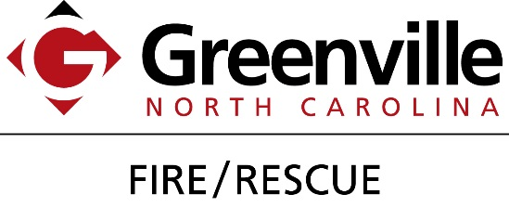  
  
  
  
  
  
Fire Prevention Week 2016  
Poster Contest Rules and Regulations**

**Rules.**

1. The contestant must be enrolled as a 1st – 8th grader.
2. The contestant must enter their poster by either dropping it off at Greenville Fire/Rescue Station 1, 500 S. Greene St., or by emailing a scanned copy to [rthurston@greenvillenc.gov](mailto:rthurston@greenvillenc.gov).
3. The contestant must enter their poster before October 7, 2016 to be eligible.
4. The contestant may choose to use this year’s theme (“Don’t Wait, Check the Date: Replace Your Smoke Alarm Every 10 Years”) but it is not necessary in order to enter or win.
5. The contestant must have their name and grade level on the back of the poster.
6. The contestant must use standard paper size (8 ½ X 11 in.) to make the poster.

**Regulations.**

1. There will be one winner from each grade level.
2. The contest will be judged by GFR personnel.
3. Each contestant will receive a coupon to Olive Garden for entering the contest.
4. Contestants are competing for coupons to AMF East Carolina Lanes and McDonald’s.
5. Winners will be announced and recognized at our “Fire & Ice” Fundraiser at Station 1, 500 S. Greene St., on Tuesday, October 18, 2016   
   at 5:00 p.m.

Any questions can be directed to Rebekah Thurston at (252) 329-4679.

***Sponsored by:***

