CMS Training – visionLive – User Manual

**2014**

Peggy L. Wooten

City of Greenville

8/15/2014

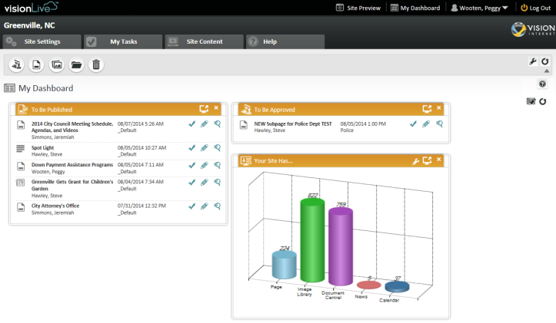

Contents

Dashboard 2

Help 5

Create (Add) Page 6

How to Add a Page 6

Edit Page 9

Edit Page Overview 9

How to Edit a Page 9

Inserting a File 12

PDF file (same steps if adding a Word, Excel, etc documents) 12

Uploading Images 13

Adding Images to a Page 15

Style Guide 17

Templates 18

Calendar Events 20

Save and Archive 22

Approver Process 23

# Dashboard

The **Dashboard**is the initial entry point page when you first log into the CMS. It can also be accessed anywhere from the CMS by clicking the **My Dashboard**link in the top navigation bar.

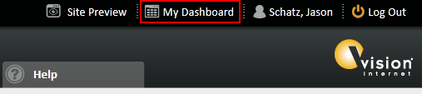

This page is a collection of site content that is specific to the individual users account. The dashboard has multiple Quick Review Blocks that can be configured for each user account.

The dashboard blocks allow you quickly to review and take action on the most recent website activities and help you manage your website. There are eight Quick Review Blocks which display tabular summaries and two Graph View Blocks which generate graph views of the activities & status of your website content. By default, it lists the 5 most recent or applicable items and it provides a link to the full page view of each block.

|  |
| --- |
| **Explanation of Quick Review Block Elements** |
| http://dev5.netvip.com/VMC/FileCenter/Images/5_Misc/Dashboard/QuickReviewBlock.jpg |

|  |  |
| --- | --- |
| **Description** | |
| numeral 1 | Dashboard Block Name |
| numeral 2 | Content Type Icon -- See [**Content Type Icons**](http://dev6.netvip.com/Greenville6/Admin#ContentTypeIcons) table below. |
| numeral 3 | Content Title or Content Name |
| numeral 4 | Last Action was taken by this user |
| numeral 5 | See "[**Date/Time Represents**](http://dev6.netvip.com/Greenville6/Admin#DateTimeRepresents)" column Quick Review Block Details table below |
| numeral 6 | Content Group (owner group of this content) |
| numeral 7 | Goes to Full Page List View of this Dashboard Block |
| numeral 8 | Remove/Delete this block from Dashboard |
| numeral 9 | Action Icons -- See [**Action Icons Description**](http://dev6.netvip.com/Greenville6/Admin#ActionIconDescriptions) table below |

|  |  |
| --- | --- |
| **http://dev5.netvip.com/VMC/FileCenter/Images/5_Misc/Dashboard/numeral-2.jpg****Content Type Icons** | **http://dev5.netvip.com/VMC/FileCenter/Images/5_Misc/Dashboard/numeral-9.jpg****Action Icon Descriptions** |
| |  |  | | --- | --- | | Pages | Page (your website pages) | | Documents | Document in Document Central | | Images | Image in Image Library | | Calendar Events | Calendar Event | | News | News | | Business Listing | Business Directory Listing | | Facility Listing | Facility Directory Listing | | FAQs | Frequently Asked Question (FAQ) | | Forms | Form (Online Form) | | Job Posts | Job Post | | Photo Album | Photo Album | | RFP | Request for Proposal (Bids/RFPs) | | Service Directory | Service Directory Listing | | Staff Directory | Staff Directory Listing | | |  |  | | --- | --- | | http://dev5.netvip.com/VMC/FileCenter/Images/5_Misc/Dashboard/Action-Approve-or-Publish.jpg | Approve or Publish this content | | http://dev5.netvip.com/VMC/FileCenter/Images/5_Misc/Dashboard/Action-Edit-Content.jpg | Edit this content | | http://dev5.netvip.com/VMC/FileCenter/Images/5_Misc/Dashboard/Action-Review.jpg | Review this content | | http://dev5.netvip.com/VMC/FileCenter/Images/5_Misc/Dashboard/Action-Unlock-Content.jpg | Unlock this content (Locked by me) | | http://dev5.netvip.com/VMC/FileCenter/Images/5_Misc/Dashboard/Action-No-Edit-Permission-Locked.jpg | No Permission to Edit this content (Locked by someon else) | |

**Quick Review Block Details**

|  |  |  |  |
| --- | --- | --- | --- |
| **Dashboard Block Name** | **Description** | **Date/Time Represents** | **Available for** |
| To Be Approved | Content to be approved for next step in approval cycle. | Last Updated | All users |
| To Be Published | Content to be published for public release. | Last Updated | All users |
| My Locked Content | Content that is locked by the currently logged in user. When content enters the “Edit” mode, it is locked from other users. This content can be edited by the currently logged in user. | Last Updated | All users |
| All Expired Content | Website contents do not require expiration dates. This view lists all content with expiration date which occurred in the past. | Expired Date | All users |
| Content in My Workflow | Content that is in my workflow if one belongs to multi-state workflow. | Last Updated | All users |
| Expiring in the Next 30 Days | Content that has expiration date within the next 30 days. | Expiration Date | All users |
| Scheduled Content Review | Content that has been scheduled for review on a regular interval or on a specific date | Scheduled Content Review Date | All users |
| All Locked Content | All locked content in the website. | Last Updated | Super users |

# Help

The Help Icon is located on each page as a “Question Mark” in the upper left corner or as “Help” as you see below. **Please Use the Help Assistance before calling the Help Desk!!**

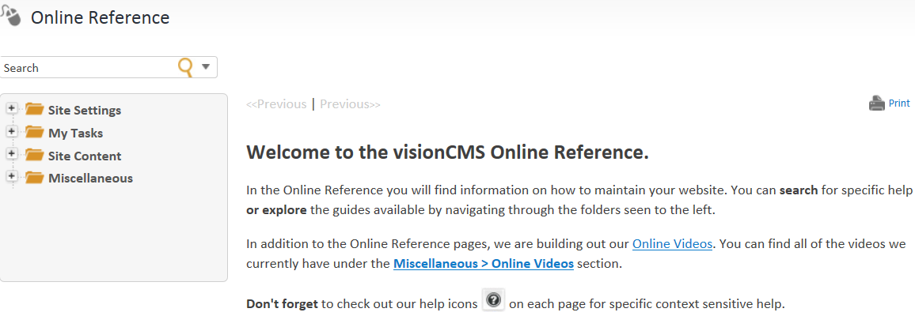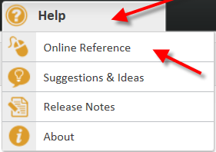

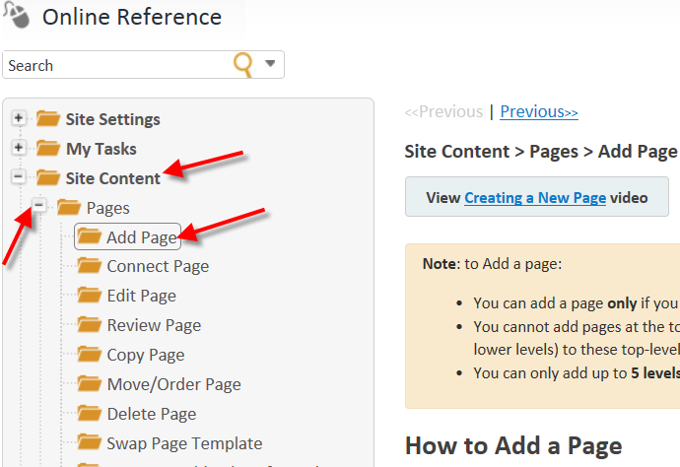

# Create (Add) Page

[Print](javascript:clickHereToPrint();)

|  |
| --- |
| **View** [**Creating a New Page**](http://dev6.netvip.com/Greenville6/Admin/Page#CreatingaNewPage) **video** |

|  |
| --- |
| **Note**: to Add a page:   * You can add a page **only** if you are in the first state of a workflow and are assigned to the appropriate content role, or if you are a [Super User](javascript:void(0);). * You cannot add pages at the top-level of the website (e.g. Home, Departments, etc.) -- you can only add new pages as subpages (in sequentially lower levels) to these top-level pages. * You can only add up to **5 levels of subpages** in the website (for a total of six navigational levels in all). |

## How to Add a Page

There are two ways to create a new page on the website:

1. While you are in the Site Preview mode, click **Add Subpage** in the Administrator's Toolbar at the top of the page. This will create a subpage under the page you clicked the Add Subpage link on.
2. Under **Site Content** in the primary CMS menu, select the **Pages** link in the dropdown menu. Use the Page tree-view to drill down to the desired level for the new page. Select a row and click one of the four Add Page actions(Add Page Above, Add Page Below, Add Subpage at Top, Add Subpage at Bottom).

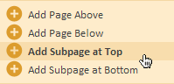

This will bring you to step 1 of the Add Page form:

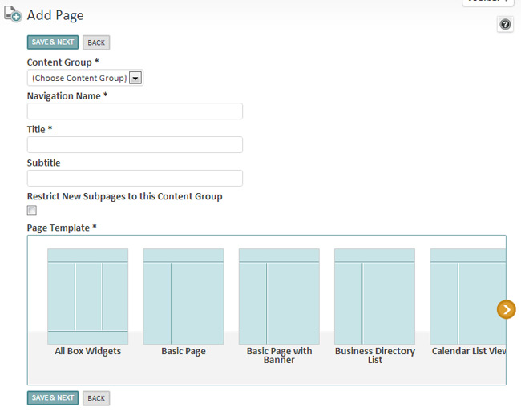

Below is an explanation of the items on the first step of the Add Page form:

|  |  |
| --- | --- |
| **Content Group** | The [Content Group](javascript:void(0);) selection indicates which group (staff) have oversight permissions for page content. Each Content Group has specified Workflows for publishing content. Select the appropriate Content Group for the page. |
| **Navigation Name** | Enter the navigational name of the page - this name will show up in the dropdown, left menu and breadcrumbs navigation of the webpage. |
| **Title** | The Title appears at the top of the page (in a predefined font style). The Page Title will most likely be the same as the **Navigation Name** you entered. |
| **Subtitle** | The Subtitle of the page appears below the Page Title (in a predefined font style). |
| **Restrict Subpage** | The **Restrict New Subpages to this Content Group** option will prevent any subpages from other content groups from being placed under the page your are editing. This will allow you to maintain control over certain areas of the site where adding content should be restricted. |
| **Page Template** | Depending on the content group selection, the available Page Template options will vary. Each page template can provide a unique layout and feature set of content within the site. There will be a number of default page template options you can use, and others that you can create. [Click here](javascript:void(0);) for more information. |

After filling out the required fields, click the **Save & Next** button at the bottom of the Page Form to proceed into the [Edit Page](javascript:void(0);) view.

**Creating a New Page Video** – when you go to Help, it’s located at the bottom of Add Page documentation

# Edit Page

|  |
| --- |
| **Note**:   * You can edit a page **only** if you are assigned to the appropriate content role, or if you are a [Super User](javascript:void(0);). * You cannot edit a page that is locked by another user. |

## Edit Page Overview

The edit view is divided into two main parts.

1. **Options Toolbar**  
   This is the green bar that appears at the top of the page. This will allow you to expand to show more options about the page, and to save and approve/publish your work. Please see the [Show All Options](javascript:void(0);) guide for more information.

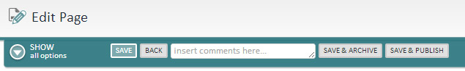

1. **Content Area**  
   The content area of the page is the area that the public will see once the page published. Each page template may have a different layout and combination of widgets on the page resulting in an infinite number of options on how your page may be formatted. You will be able to configure these widgets differently for each page created resulting in unique content for your site visitor.

## How to Edit a Page

There are two ways to edit an existing page on the website:

1. While you are in the Site Preview mode, click **Edit Page** in the Administrator's Toolbar at the top of the page.
2. Under **Site Content** in the primary CMS menu, select the **Pages** link in the dropdown menu. Use the Page tree-view to drill down to the desired page. Select a row and click to open the **Edit (& View more Info)** action from the dropdown.

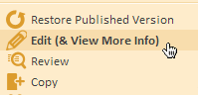

This will bring you into the Edit mode of the page form. Since the site uses numerous [Page Templates](javascript:void(0);), the **Edit Page** view (below) will show a layout unique to the page that you are editing. The view you see here is intended to showcase a true representation on what the public will see.

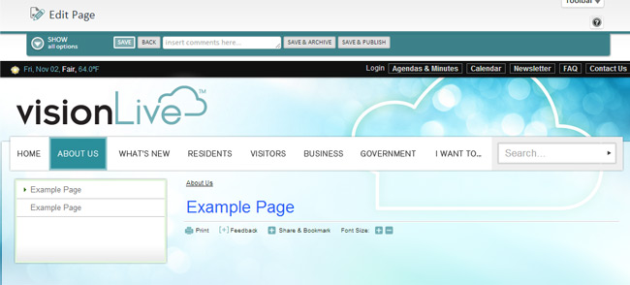

Upon initial load various [widgets](javascript:void(0);) will appear on the page according to how the page template was setup. Simply hover your mouse around the page to show the outlines for the widgets on the page.

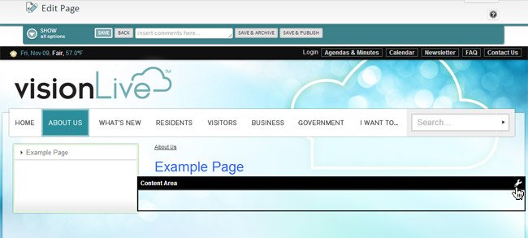

Click the wrench "settings" icon in the corner of that widget to edit it (if desired). The example below shows a Content area widget being opened.

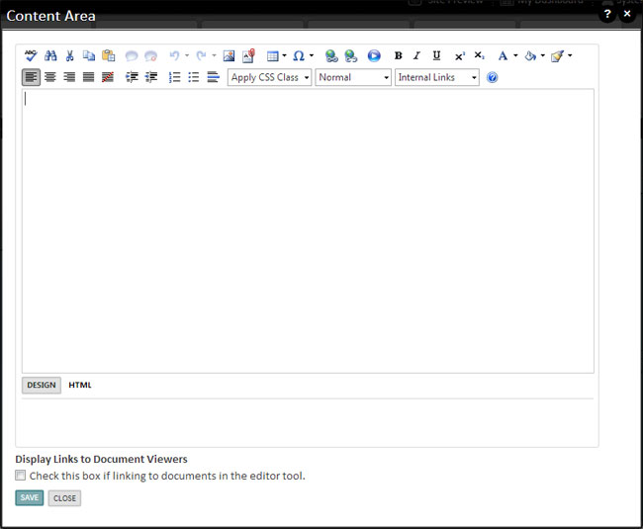

Once all the information has been entered, click a SAVE action from the Options Toolbar so save the page and be taken back to the main Pages list.

Please read the following guides for more information on how to edit a page.

# Inserting a File

## PDF file (same steps if adding a Word, Excel, etc documents)

1. Highlight Current Words for the Link

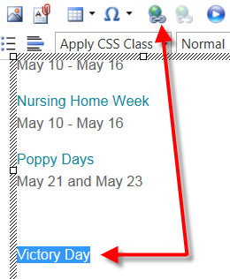



1. – Click button to Choose File

1. Choose File
2. Click Insert

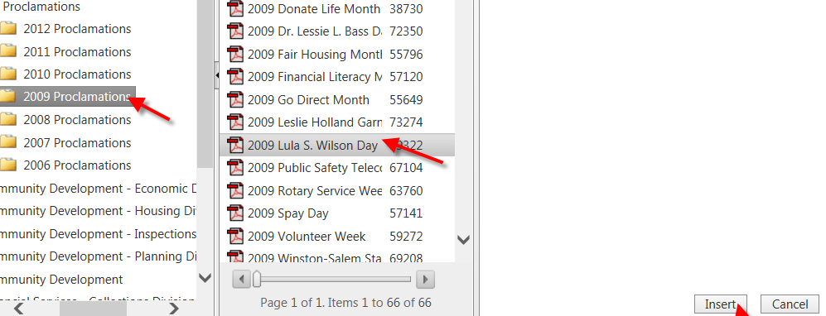

1. Click OK
2. Save
3. Type in “comment here”, then click Save & Archive



1. Save and Publish



# Uploading Images

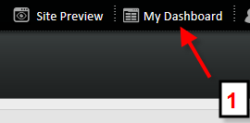

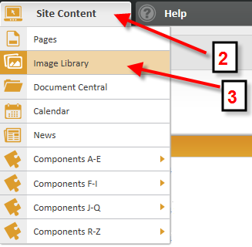

Add to Root Folder (Department name: Example: Fire Rescue) if the image is going to be used site wide

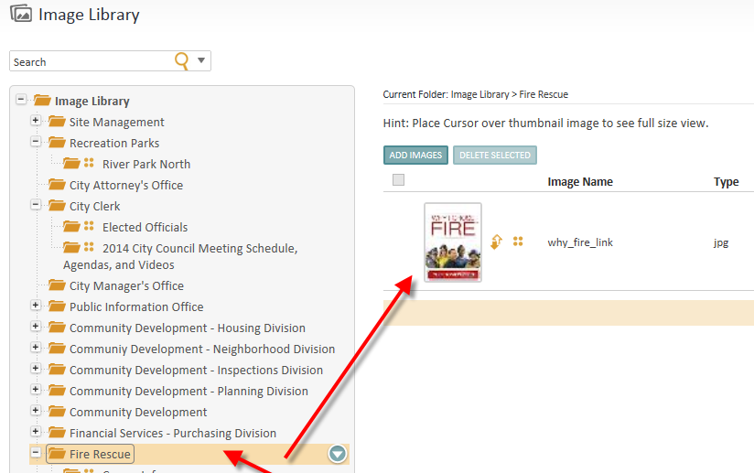

Add to the Page Folder (Department page: Fire Rescue Station and Equipment) if image is going to be used only for this page

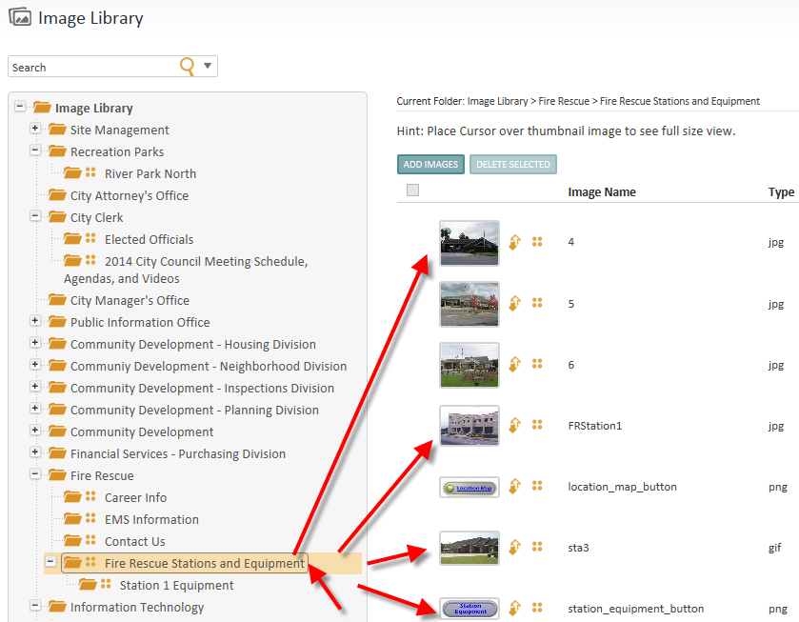

# Adding Images to a Page

Type info here

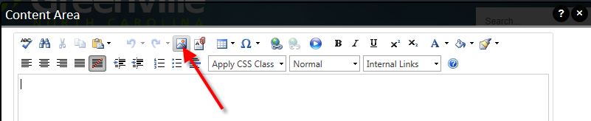

Click on Image Icon (see above)

Click on Folder where the image (s) is located

Select Image > Click Insert

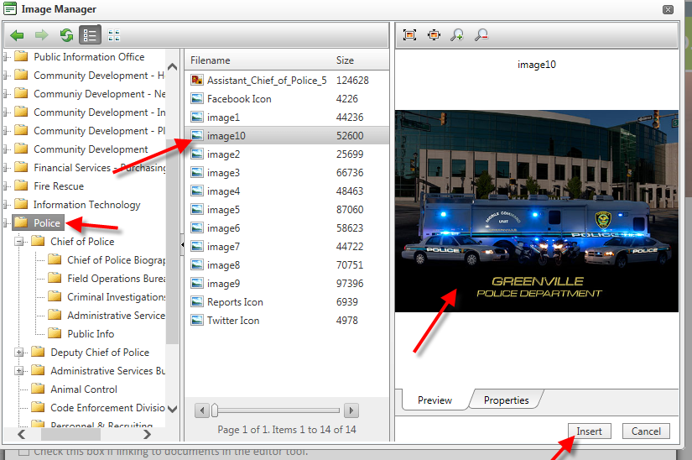

Image can be resized by pointing mouse at any of the 8 thumbnail boxes around the picture, then the mouse pointer turns into a two way arrow then you can decrease of increase the picture size

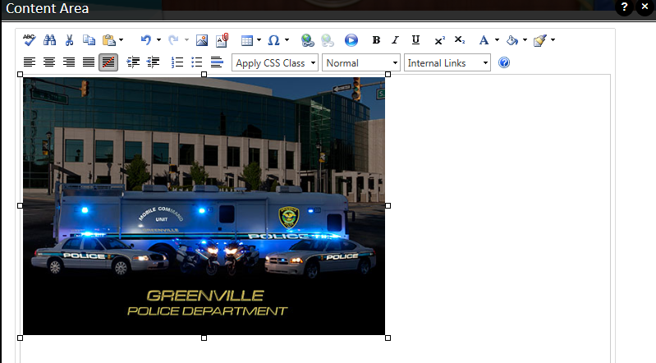

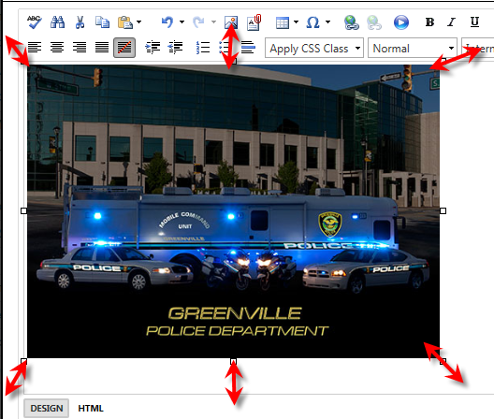

OR Resize Manually

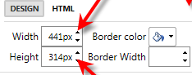

After inserting the Picture > Click Save

# Style Guide

Type info here (Font, Text – to be given by Steve Hawley)

# Templates

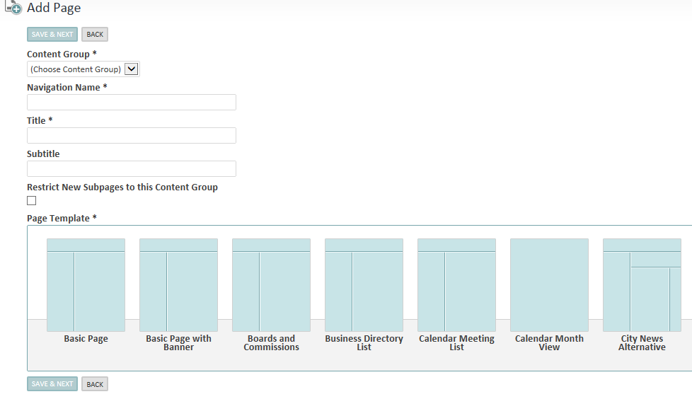

Once you select the Department Name, For Example: Police – your selection of templates display according to your department

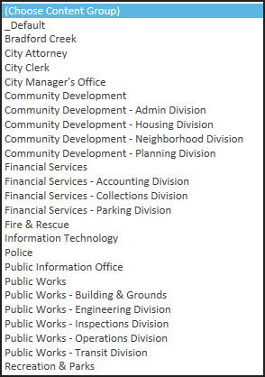

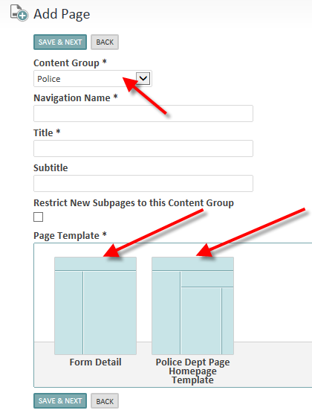

Fill out or select option for any required field with an **\*** asterisk beside it (this is a required field)

# Calendar Events

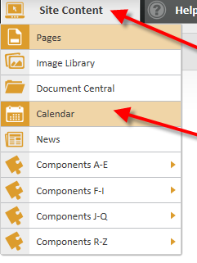

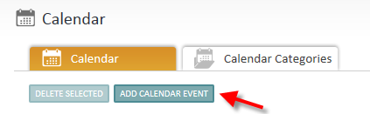

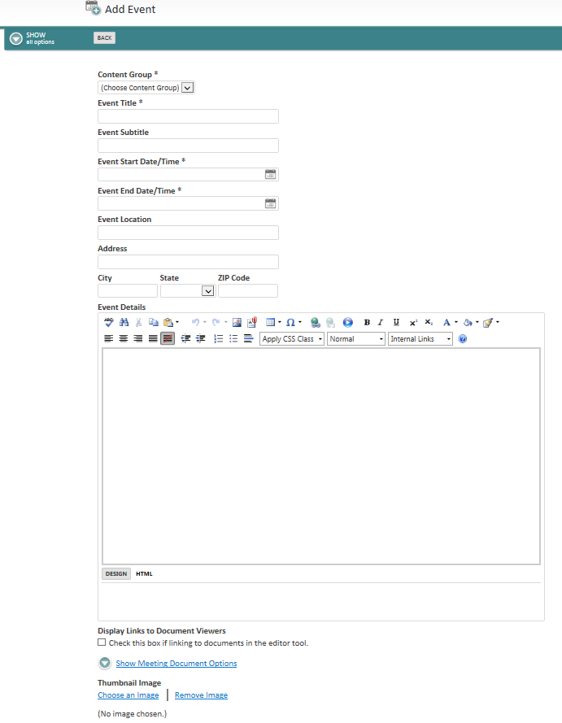

# Save and Archive

**\***Importance of Save and Archive**\***

* Save and Archive will allow you to have a page to go back to incase you change or delete some information by mistake.

Enter Comments First



Click Save & Archive



# Approver Process

1. Click My Tasks
2. Awaiting My Approval

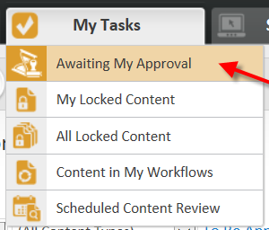

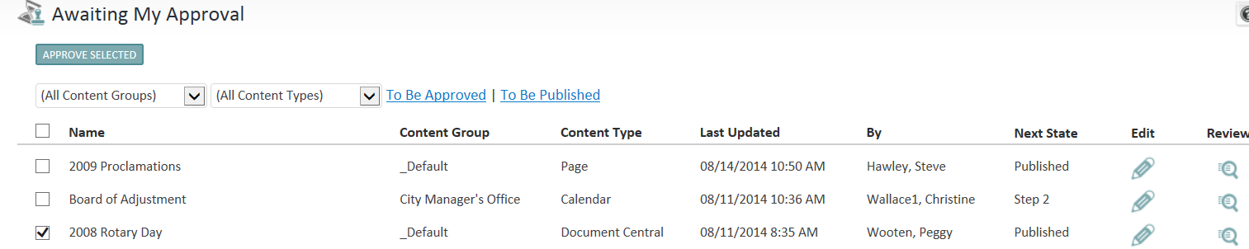

1. Click on Page to approve
2. Click Approve Selected button

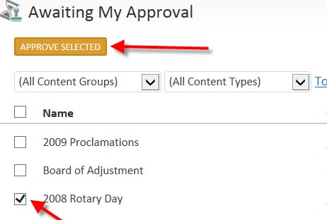Message Approved will display 