

SAMPLE FIRE EMERGENCY GUIDE
123-127 My Street

This guide has been prepared to let you know of the fire safety features of your building.

In the event of a fire emergency inside,
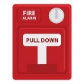
- Leave your apartment immediately and close the door behind you
- Call 9-1-1
- Pull the Fire Alarm (if available)
- Once outside, go to the designated meeting place
- Do not return to the building until the fire department has said it is safe to re-enter

Your apartment building is equipped with fire safety equipment and appliances that are designed to protect you.

Smoke Alarms
- Option 1 (electric powered):
Each unit is equipped with a smoke alarm. The smoke alarms are powered by electricity and have a battery backup in the event of a power failure. These smoke alarms need to be replaced every 10 years. The smoke alarm has a hush feature. This will allow you to silence it in the event something other than a fire causes the alarm to sound.

- Option 2 (battery powered):
Each unit is equipped with a smoke alarm. Most new smoke alarms are solely powered by a 10-year battery. Older smoke alarms that need the batteries changed yearly will need to be replaced every 10 years. The smoke alarm has a hush feature. This will allow you to silence it in the event something other than a fire causes the alarm to sound.

In order to make sure the smoke alarm remains operative, please do the following:
- Test the smoke alarms monthly
- Change smoke alarm batteries for battery powered alarms annually unless equipped with a 10-year battery
- Never remove, cover, or disable a smoke alarm
- Contact on-call maintenance staff immediately if you discover a problem with a smoke alarm


Carbon Monoxide Alarms (only required when there is a carbon monoxide source)
Each unit is equipped with a carbon monoxide alarm within 5 feet from each bedroom. The carbon monoxide alarm is designed to sound when there is a level of carbon monoxide that is dangerous present. Carbon monoxide is an invisible and odorless gas that is toxic and can be created from incomplete combustion of natural gas, propane, or vehicle exhaust. Carbon monoxide can kill you!

If your carbon monoxide alarm sounds, please do the following:
- Press the test or reset button on the alarm.
- If the alarm continues to sound
  - Evacuate everyone from your apartment
  - Call 9-1-1
  - Follow the recommendations of the firefighters
- Contact on-call maintenance staff immediately if you discover a problem with a smoke alarm

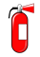
Portable Fire Extinguishers
- Option 1 (Exterior):
Fire extinguishers are located on the exterior of building. These extinguishers can be used by residents to put out a fire if safe to do so. Please familiarize yourself with where the fire extinguishers are in the event that you need to use one. You will see them located on the emergency evacuation plan diagram.
Remember the acronym PASS which stands for Pull the pin, Aim the nozzle, Squeeze the handle, and Sweep the nozzle side to side.
- Option 2 (Interior):
A fire extinguisher is located inside each dwelling unit. These extinguishers can be used by residents to put out a fire if safe to do so. Please familiarize yourself with where the fire extinguishers are in the event that you need to use one. You will see them located on the emergency evacuation plan diagram.
Remember the acronym PASS which stands for Pull the pin, Aim the nozzle, Squeeze the handle, and Sweep the nozzle side to side.

SAMPLE EMERGENCY EVACUATION PLAN



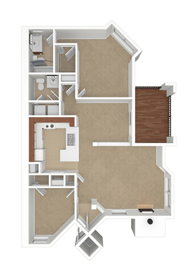

Greenville Blvd




