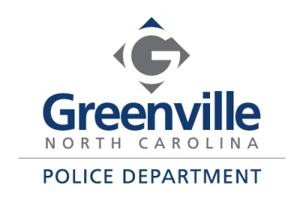

500 S. Greene Street Mark Holtzman
Greenville, NC 27834 Chief of Police

Greenville Police Department
Animal Protective Services Division
Monthly Report
April 2021
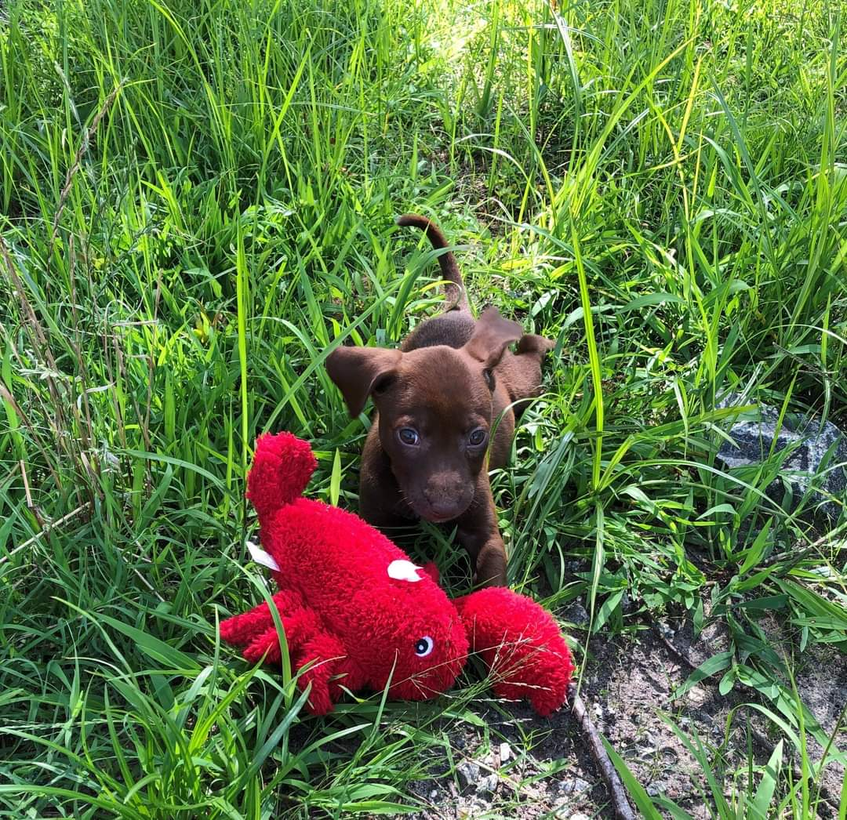

The Greenville Police Department Animal Protective Services Division serves approximately 95,000-105,000 citizens and intakes approximately 500-1000 animals each year. Through the hard work of our dedicated APS Officers, Police Officers, agency partners, and rescue partners, we continue to improve the lives of the animals that come into our care while also improving public health and safety.

Please check our website at https://www.greenvillenc.gov/government/police/animal-protective-services for more information. To view animals that are currently in the custody of the division please visit https://www.petango.com/gpdaps.

Mission Statement

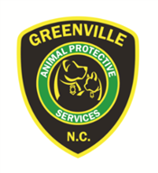
The mission of the Greenville Animal Protective Services Unit is to promote responsible pet ownership and animal welfare. We strive to provide quality service to the citizens, while dedicating ourselves to improving the co-existence of animals and humans.

Incoming Animals Monthly Comparison

Incoming animals include all animals that enter the custody of the Division through pickup by an APS officer or Police Officer.

Outgoing Animals Monthly Comparison
Outgoing animals include owner reclaims and transfers to a rescue group or transfer partner.

Euthanasia Monthly Comparison

Incoming animals may be euthanized for a variety of reasons including for space, health, injury, or temperament. We do not provide owner requested euthanasia to the public.

Animal Protective Services Statistical Report

This report shows the current report month statistics and compares fiscal year to date statistics for the current fiscal year and the prior three fiscal years.

Date Range: July 1, 2020 – April 30, 2021 |  |  |  |  |  | Date Prepared: 5/4/2021
 | YTD FY18 | % | YTD FY19 | % | YTD FY20 | % | YTD FY21 | % | MTD FY21 | %
Intake Dog | 360 |  | 314 |  | 345 |  | 250 |  | 22
Intake Cat | 106 |  | 140 |  | 283 |  | 129 |  | 9
Intake Other | 71 |  | 76 |  | 33 |  | 27 |  | 10
Intake Total | 537 |  | 530 |  | 661 |  | 406 |  | 41
Transfer Dog (Rescue) | 12 | 85.7% | 7 | 36.8% | 63 | 79.7% | 133 | 80.1% | 4 | 66.7%
Transfer Cat (Rescue) | 1 | 7.1% | 5 | 26.3% | 12 | 15.2% | 30 | 18.1% | 2 | 33.3%
Transfer Other (Rescue) | 1 | 7.1% | 7 | 36.8% | 4 | 5.1% | 3 | 1.8% | 0 | 0.0%
Transfer to Rescue Total | 14 | 2.6% | 19 | 3.6% | 79 | 12.0% | 166 | 40.9% | 6 | 14.6%
Transfer Dog (PCAS) | 227 | 72.1% | 181 | 70.7% | 174 | 57.4% | 23 | 82.1% | 6 | 100.0%
Transfer Cat (PCAS) | 87 | 27.6% | 75 | 29.3% | 129 | 42.6% | 5 | 17.9% | 0 | 0.0%
Transfer Other (PCAS) | 1 | 0.3% | 0 | 0.0% | 0 | 0.0% | 0 | 0.0% | 0 | 0.0%
Transfer to PCAS Total | 315 | 58.7% | 256 | 48.3% | 303 | 45.8% | 28 | 6.9% | 6 | 14.6%
Reclaim Dog | 98 | 98.0% | 89 | 98.9% | 86 | 91.5% | 78 | 84.8% | 11 | 91.7%
Reclaim Cat | 2 | 2.0% | 1 | 1.1% | 8 | 8.5% | 12 | 13.0% | 0 | 0.0%
Reclaim Other | 0 | 0.0% | 2 | 2.2% | 0 | 0.0% | 2 | 2.2% | 1 | 8.3%
Reclaim Total | 100 | 18.6% | 90 | 17.0% | 94 | 14.2% | 92 | 22.7% | 12 | 29.3%
Euth Dog | 10 | 15.4% | 32 | 26.2% | 12 | 9.2% | 18 | 14.3% | 1 | 7.1%
Euth Cat | 26 | 40.0% | 46 | 37.7% | 90 | 69.2% | 87 | 69.0% | 5 | 35.7%
Euth Other | 29 | 44.6% | 44 | 36.1% | 28 | 21.5% | 21 | 16.7% | 8 | 57.1%
Euth Total | 65 | 12.1% | 122 | 23.0% | 130 | 19.7% | 126 | 31.0% | 14 | 34.1%

 | Total | %
Change in intake from FY20 to FY21 | -255 | -38.6%
Change in transfers to PCAS from FY20 to FY21 | -275 | -90.8%
Change in transfers to rescues from FY20 to FY21 | +87 | +110.1%
Change in euthanasia from FY20 to FY21 | -4 | -3.1%

Animal Protective Services Division Transfer Program
Transfer and rescue partners pull animals from the Greenville Holding and Transfer Facility into their programs. Our partners are both near and far with partners across North Carolina and the United States. We are fortunate to have the transfer partners we have and are always looking to add more! They assist us to increase our live release rate as well as allow animals that are victims of cruelty to go to specialized rescues for rehabilitation. To learn more about becoming a transfer partner with the Animal Protective Services Division please contact the APS Supervisor at jbreece@greenvillenc.gov.

During April 2021, 6 animals were transferred to various transfer partners. Thank you to all of our Transfer Partners that pulled animals from our holding facility. Every animal that is able to be transferred is important!

