**TRAINEE RECRUITMENT PACKET**

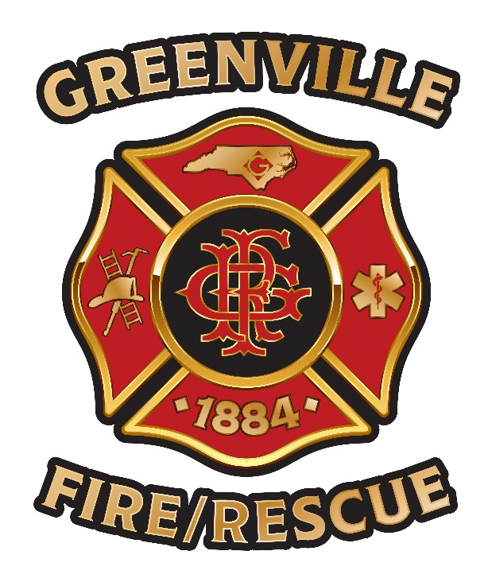

JOIN OUR TEAM

## The City of Greenville Fire/Rescue Department is recruiting men and women to become fire/rescue professionals. We seek motivated individuals who want to be part of a progressive, innovative fire/rescue department. Our goal is to have a workforce that reflects the diversity of our community. Women and minorities are especially encouraged to apply.

The following information is provided to assist prospective Greenville Fire/Rescue members. We hope you will be successful in your pursuit of a career with Greenville Fire/Rescue.

Academy 21

**GREENVILLE FIRE/RESCUE DEPARTMENT**

### Recruiting Fact Sheet

**ABOUT THE GREENVILLE FIRE/RESCUE DEPARTMENT:**The Greenville Fire/Rescue Department is made up of 176 proud men and women spread across three individual work shifts who each work 24-hour shifts. We serve the community through six neighborhood-based fire/rescue stations.

**THE WORK:** Fire/Rescue employees perform a full range of activities, including firefighting, emergency medical services, community service programs, continuing education/training, and station maintenance. Our employees are highly skilled professionals who provide a unique service-oriented approach to citizens' safety. The fire/rescue business is one of the noblest callings that one could ever have. It provides many activities, ample opportunities to grow professionally, and is constantly changing. Those that depend upon the status quo and a static workplace might not be well-suited for this type of work. However, if you like a fast-paced work life, have a genuine desire to work as part of a team, and place service above self, then we would love to have you as part of our team.

**PREREQUISITES FOR APPLICATION:** All applicants must:

* Be at least 18 years of age.
* Have a high school diploma or possess a GED equivalent.
* Have a valid driver’s license and a safe driving record.
* Be a United States citizen or a non-citizen who can provide proof of identity and authorization to work in the United States.
* Be of good moral character.
* Possess the mental, physical, and medical health to perform the duties of a Fire/Rescue Trainee.
* Be highly motivated and interested in the fire/rescue field.

While knowledge or experience of the fire/emergency medical service is helpful, *it is not required.* The City of Greenville will provide and pay for training for all new Fire/Rescue Trainees to ensure that you have the skills and knowledge necessary to perform the job.

**SALARY AND BENEFITS:** Salary upon employment (Fire/Rescue Trainee) - $39,728.00/annually. Employees receive a generous package of benefits, including:

* Health, dental, and vision insurance
* Life insurance
* 13 paid holidays per year plus 1 floating holiday
* Paid vacation and sick leave
* Wellness benefits and paid gym memberships
* Tuition Assistance
* Membership in the state retirement system, with option to enroll in supplemental retirement plans
* Credit union membership
* Uniforms and equipment
* Employee Health Clinic

WORK HOURS: Fire/Rescue Trainees participate in a four to six-month, 40-hour per week paid training program. Upon completion of training, employees are assigned to a shift and work a 24-hour shift on duty, with two days (48 hours) off between shifts. Fire/Rescue members assigned to shifts will work an average of ten 24-hour shifts per month. During their shift, members live and eat at the fire/rescue station.

**HIRING PROCESS:** Applicants must successfully pass all the following steps in order to complete the hiring process:

### Physical Performance Test | Orientation (optional).

This is a pass/fail test. The test consists of eight physical tasks that are representative of actions typically performed by Fire/Rescue members. Refer to the pages that follow for a description of the Physical Performance Test.

### Oral Interview Panel Interviews & Chief Interviews

### The Greenville Fire/Rescue Department conducts two rounds of oral interviews. Selected applicants who pass the Physical Performance Test are invited to participate in the first interview conducted by an Assessment Board of the Greenville Fire/Rescue Department. Selected candidates will be invited to participate in the *second* interview conducted by the Fire/Rescue Chief and/or Deputy Fire/Rescue Chief.

### Background Check

A comprehensive background investigation (including references, work history, criminal, and driving records) is conducted on applicants to establish evidence of good moral character and a pattern of conduct acceptable to the Greenville Fire/Rescue Department. A criminal conviction will not automatically eliminate you from the process. We consider the crime committed when it occurred, your age, the relationship between the crime, and your position as a Fire/Rescue Trainee. A misstatement of fact or omission of the requested information is grounds for automatic rejection before appointment or termination after employment.

An applicant will be removed from consideration whose overall background is deemed undesirable. Evidence of undesirability includes, but is not limited to:

* + Demonstrated pattern of lack of responsibility (school, jobs, financial matters, etc.);
  + Demonstrated pattern of problems with interpersonal relationships;
  + Demonstrated disregard of local, state, and/or federal laws;
  + Incidents of deception (including efforts to deceive in this process);
  + Poor employment record;
  + Poor driving record.

### Psychological Evaluation

Selected candidates are scheduled for a psychological evaluation to determine their current suitability as a Fire/Rescue member.

### Medical Examination and Drug Screen

### Selected candidates who successfully complete the psychological evaluation will be scheduled for a complete medical examination and drug screen. The medical examination determines whether the candidate is medically qualified to perform the full range of Fire/Rescue Trainee duties. Upon satisfactory completion of the medical examination, drug screen, and Chiefs’ interview, you may be offered employment (subject to vacancies) and will be informed as to any other details that need to be addressed to prepare you for the training program.

### Greenville Fire/Rescue Department

Physical Performance Test

The Physical Performance Test consists of eight separate events, which are all directly related to normal fire/rescue tasks, such as ladder carry, hose advance, ventilation, hose carry, ladder extension, hose and rope hoist, and citizen assist. All eight events are a pass/fail test. If an applicant does not pass any one event, the applicant will be eliminated. The eight events will be timed from start to finish for our records. Each applicant should try to complete all eight events in the shortest time possible; however, to ensure the highest level of safety and to prevent exhaustion, no running is allowed during or between events. Passing or failure of the physical performance test is determined by successful completion of all eight events, not the total time used to complete the events.

An applicant may stop to rest ONLY between events. Regardless of the number of times resting between events, the total rest time for all eight events may not exceed 60 seconds. An applicant must complete each event and cannot stop during any event. If an applicant stops for more than 60 seconds (total combined time) between events or stops to rest at all during any event, the applicant will be eliminated.

Each applicant will be fitted with a weighted vest (without mask and hose) weighing 30 pounds to simulate the weight of self-contained breathing apparatus. A helmet, turnout coat, and gloves are provided for applicant protection.

**Event 1 - High Rise**: Applicant carries 100 feet of 1.5-inch double jacketed hose weighing approximately 36 pounds to the fourth floor of the training tower.

**Event 2 - Hose and Rope Hoist:** Applicant pulls 50 feet of 2.5-inch double jacketed hose weighing approximately 36 pounds to the fourth floor with a rope until the last coupling enters the window.

**Event 3 - Confined Space Crawl**: Consists of a piece of 24” corrugated tubing, 20’ long that the candidate must crawl through. It has one 90 degree turn approximately 10’ into its total length. This simulates crawling in a limited visibility space.

**Event 4 -** **Ventilation:** Using a Keiser Force Machine, applicant uses an 8-pound sledgehammer to move a weight along a track. This exercise simulates a ventilation stroke with an axe.

**Event 5 - Ladder Extension:** Applicant extends fly section of a 35-foot ladder by pulling on a rope.

**Event 6 - Ladder Carry:** Applicant removes a 14-foot aluminum ladder from a fire truck or a rack and carries the ladder 50 feet. The rack is at an approximate height of 6 to 7 feet and the ladder weighs approximately 45 pounds.

**Event 7 -** **Hose Advance:** Applicant drags 100 feet of 2.5-inch double jacketed uncharged fire hose 100 feet marked by an orange cone.

**Event** 8 - **Firefighter/Citizen Assist (Rescue):** Applicant must move/drag a 165-pound mannequin 75 feet. This event is designed to simulate the critical task of removing a person from a fire/emergency scene.

Doc 1085451