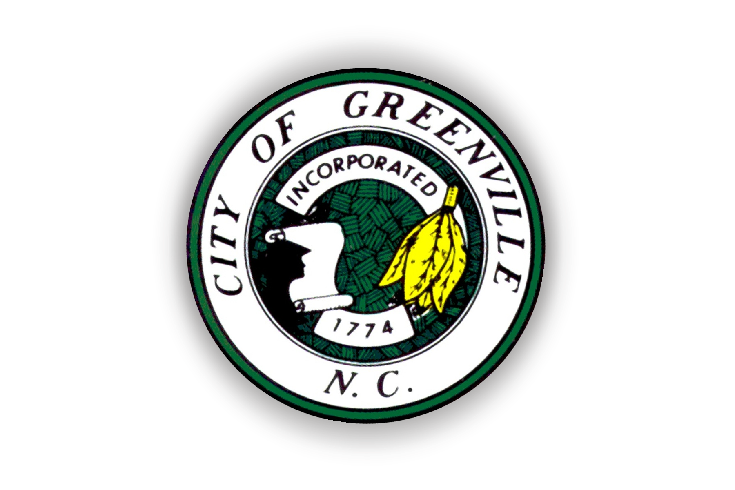
City of Greenville
P.O. Box 7207
Greenville, NC 27835

Outdoor Amplified Sound Application Checklist

Thank you for expressing interest in obtaining an Outdoor Amplified Sound Permit. It is our goal to assist you with planning a successful event. Below are a few things to consider while completing your application:

* Outdoor Amplified Sound Permit Applications can be obtained in the Greenville Police
Department Records Section Monday – Friday between 9:00 a.m. – 5:00 p.m.

*A non-refundable application fee of $50.00 must be paid at the Greenville Police
Department Records Section located inside the Police Department at 500 S. Greene Street.
Checks or money orders should be made payable to the City of Greenville. This fee is
required for each application.

* Types of events requiring an Outdoor Amplified Sound Permit include, but may not be
limited to:

- Events involving a live band
- Events involving a DJ
- Any event involving the use of sound amplification equipment. This includes
the use of a megaphone.

* Applicants will be required to indicate whether or not alcohol will be provided, or
otherwise available at the event.

* The Greenville Police Department may require the hiring of off-duty Greenville Police
Officers to staff the event. In these cases, the applicant will be required to sign a contract
outlining the terms of such employment prior to the application being approved.

* The Greenville Police Department reserves the right to deny Outdoor Amplified Sound
Permit Applications based on provisions outlined in the Greenville City Code.

* Applications must be turned in no later than 3 days prior to your event.

* Once your application has been approved, you will be contacted and advised to pick up a
copy of your permit at the Greenville Police Department Records window. This is located
in the front lobby of the Greenville Police Department and is open Monday – Friday from
9:00 a.m. – 5:00 p.m.

Any questions relating to this application process should be directed to the Logistics Division Commander at (252) 329-4101.

