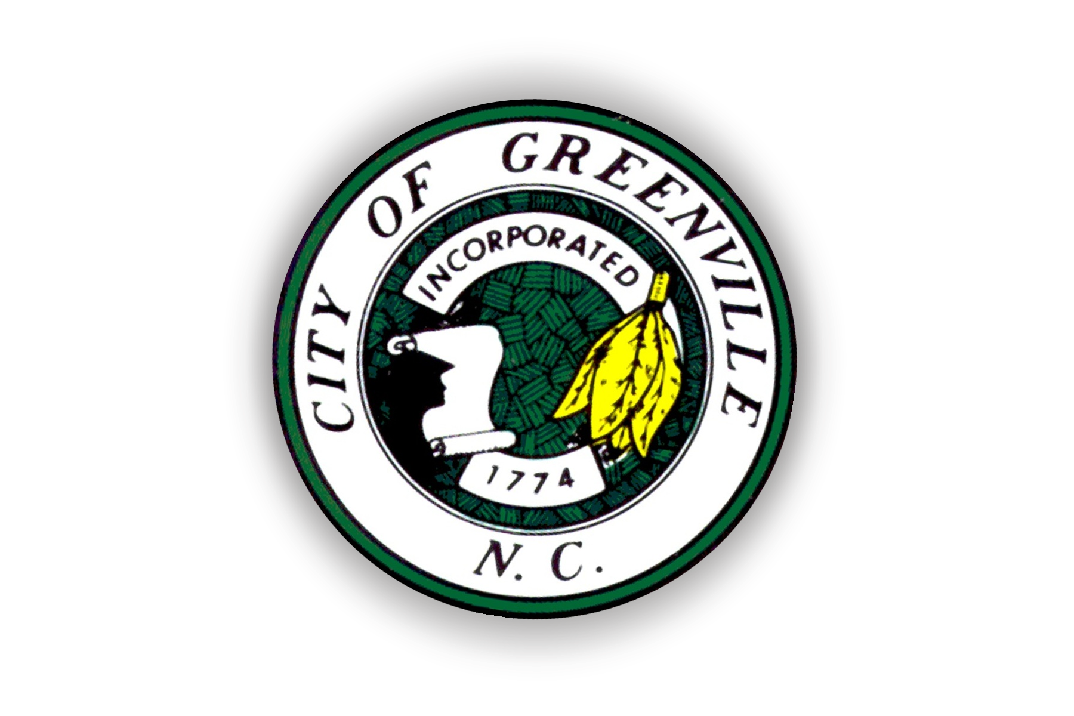
City of Greenville
P.O. Box 7207
Greenville, NC 27835

Parade Permit Application Checklist

Thank you for expressing interest conducting your event in the City of Greenville. It is our goal to assist you with planning an event that will be both successful and safe for all participants. Below are a few things to consider while completing your application:

* Parade Permit Applications can be obtained in the Greenville Police Department Records
Section Monday – Friday between 9:00 a.m. – 5:00 p.m.

*A non-refundable application fee of $50.00 must be paid at the Greenville Police
Department Records Section located inside the Police Department at 500 S. Greene Street.
Checks or money orders should be made payable to the City of Greenville. This fee is
required for each application.

* Types of events requiring a Parade Permit include, but may not be limited to:

- Traditional parades
- Organized walks which will occupy a portion of the roadway
- Foot or bicycle races and other types of runs which will occupy a portion of the roadway
- Motorcycle or car charity rides

* Applicants will be required to list the route they wish to use for their event. However, the
Greenville Police Department shall have the final authority in determining the route.

* Applicants will be required to hire off-duty Greenville Police Officers to work events requiring a Parade Permit based on the type of event. Applicants will be required to pay a fee of $30.00 per hour for each officer assigned, minimum of three hours, and a fee of $25 per vehicle prior to the date of the event.

* The applicant will be required to sign an Off-Duty Contract provided by the Greenville Police Department Logistics Division specifying the fees associated with the assignment of officers and vehicles for the event.

* The Greenville Police Department reserves the right to deny Parade Permit Applications
if staffing is unavailable. If you have questions about a particular date, please contact the
Greenville Police Department Logistics Division prior to submitting your Parade Permit
Application.

* Once your application has been approved, you will be contacted and advised to pick up a
copy of your permit at the Greenville Police Department Records window. This is located
in the front lobby of the Greenville Police Department and is open Monday – Friday from
9:00 a.m. – 5:00 p.m.

Any questions relating to this application process should be directed to the Logistics Division Commander at (252) 329-4101.

